**PROJECT SOURCE CODE AND PROJECT REPORT**

[**TOURS AND TRAVELS MANAGEMENT SYSTEM PROJECT SOURCE CODE**](https://sites.google.com/site/tprojectmebad/home/TOURS%20AND%20TRAVELS%20MANAGEMENT%20SYSTEM%20PROJECT%20SOURCE%20CODE.rar?attredirects=0&d=1)

[**TOURS AND TRAVELS MANAGEMENT SYSTEM PROJECT REPORT**](http://ignousupport.blogspot.in/p/tours-and-travel-management-system.html)

**SPONSORED LINKS**

**Tours and Travel Management System**

**Introduction**  
  
The Tours and Travel Management System is a web based application. The main purpose of “Tours and travels management system ” is to provide a convenient way for a customer to book hotels, flight, train and bus for tour purposes. The objective of this project is to develop a system that automates the processes and activities of a travel agency. In this project, We will make an easier task of searching places and for booking train, flight or bus. . In the present system a customer has to approach various agencies to find details of places and to book tickets. This often requires a lot of time and effort. We provide approach skills to critically examine how a tourist visits and its ability to operate in an appropriate way when dealing with the consequences of tourism, locally, regionally, and nationally including visitor security and ecological influences. It is tedious for a customer to plan a particular journey and have it executed properly. The project ‘Tours and Travels Management System’ is developed to replace the currently existing system, which helps in keeping records of the customer details of destination as well as payment received.   
  
**Objectives**  
  
This application is develop to provide best travelling services to the customers and travel agents. We have developed tours and travel management system to provide a search platform where a tourist can find their tour places according to their choices. This system also helps to promote responsible and interesting tourism so that people can enjoy their holidays at their favorable places. This system also helps to develop tourism with different cultures so that they enrich the tourism experience and build pride. We develop this system to create and promote forms of tourism that provide healthy interaction opportunities for tourists and locals and increase better understanding of different cultures, customs, lifestyles, traditional knowledge and believes. This system also provide a better way to connect with various events.   
  
This system also gives tours related information like which places are tourist attractions, cities, and provinces. Tourist can also get the Map and navigation system and temperature and weather information. Tourist can also book tours through our tours and travels management system. This system also keeps a history of visited places of its users.   
  
Below are the modules of this application 

**Modules of travel and tour management system**

**User Management**  
  
a. Login.   
  
b. User profile.   
  
c. Update information.   
  
d. Role based rights. 

**Administrator module :**

This module provides administrator related functionality like from this module use can add route information, bus information, train information, flight information, tour packages, travel packages, bus seat details, etc. From this module Admin can view daily, weekly and monthly report. This module is develop for admin of the website and admin can add, delete, edit and view the data related to places, travels, routes, bookings from this module.   
  
a. Manage user information.   
  
b. Update information.   
  
c. Manage Trips.   
  
d. Manage Transportation.   
  
e. Manage hotel, Bookings.   
  
  
  
**Hotel Module**  
  
Details of the hotels in which the accommodation of the customer will be done during the tours. Details like availability of meals, station-pickup and drop facility and  
contact no. of the hotels are also provided to the customers on special request.   
  
a. Registration (as user)   
  
b. Registration (as Hotel)   
  
c. Search   
  
  
**Transportation Module**  
  
a. Flight   
  
b. Train   
  
c. Bus   
  
**Package Modules**  
  
User can view different tour packages available for tourist. User can select any packages from this module he can also check the details of various travel agencies. A user can select any travel agency from this module.   
  
  
**Testimonials module :**  
  
This is testimonials module where passenger can post feedback after the journey and they can share their experience. Users of this application can post their opinions, complaints and suggestions regarding   
  
a. Photos   
  
b. Videos   
  
  
  
**Payment Module**  
  
a. pay payment through PayPal   
  
b. pay payment through Draft  
  
  
**Search Module**  
  
a. search City wise hotels, flights, packages, bus, rails and events.   
  
  
  
**Routes module:**  
  
This will display the route information of Source location and destination location. Use can also check bust routes for his destination. User can check bust rout train tout and car rout for his journey and can select any rout packages from the available tour packages. From this module use can also get information related to various routes connecting sources and destinations. For each route, information such as source, destination, fare, reservation details, pick up points etc are provides.   
  
  
  
**Reservations module:**  
  
This module is for passengers where passenger can reserve the seats by making payment. Using this module user can book bus ticket or train ticket. From this module user can also book tickets or cancel previously booked tickets. The module maintains the details of all reservations made so far and allows administrator to either confirm or reject the bookings.   
this portal and services to the administrator. Accordingly, the administrator can take various steps to act on the complaints and suggestions.   
  
**Tour Details :**  
  
  
Details of different types of tours which includes tours like family tours, couple tours, general tours, date and time of departure and the fair of the tours etc are maintained. As the customer ask for the details of a particular tour, the tours and travel management system gives the details of the related place where tourist wants to go and the date and time of the tour, no. of seats available of that particular tour, fair of the tour, details of discount on a particular tour package if any. Details of the pick-up facilities and the drop facilities are also maintained if any. 

**DFD -  DATA FLOW DIAGRAM OF TOURS AND TRAVEL MANAGEMENT SYSTEM**

**CONTEXT LEVEL DFD**

[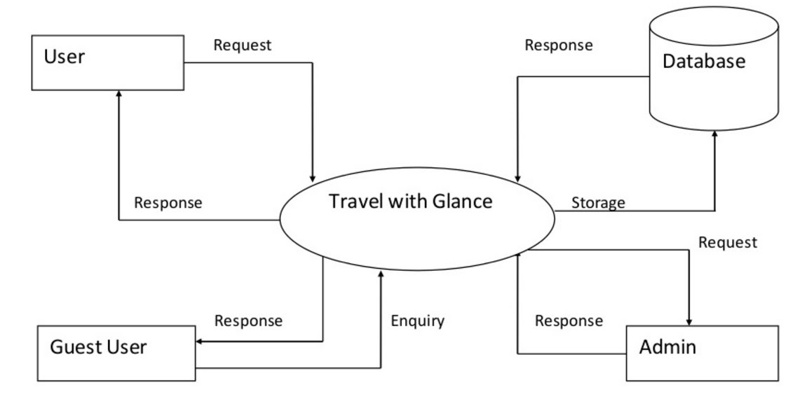](https://sites.google.com/site/ignoubcafinalyearprojects/project-report/tours-and-travel-management-system-project-report/CONTEXT%20LEVEL%20DFD%20-%20TOURS%20AND%20TRAVELS%20MANAGEMENT%20SYSTEM.jpg?attredirects=0)

**ADMIN LEVEL 1 DFD**

**[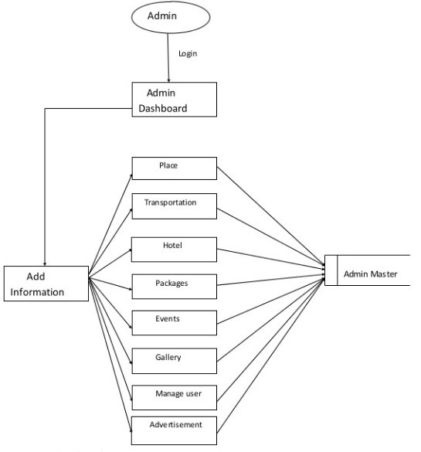](https://sites.google.com/site/ignoubcafinalyearprojects/project-report/tours-and-travel-management-system-project-report/1%20LEVEL%20DFD%20-%20TOURS%20AND%20TRAVELS%20MANAGEMENT%20SYSTEM.jpg?attredirects=0)**

**USER LEVEL 1 DED**

**[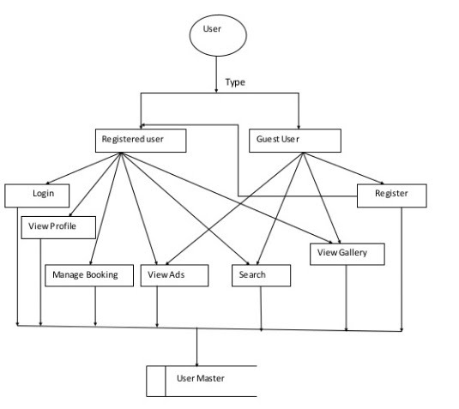](https://sites.google.com/site/ignoubcafinalyearprojects/project-report/tours-and-travel-management-system-project-report/1%20LEVEL%20DFD%20-%20USER%20-%20TOURS%20AND%20TRAVELS%20MANAGEMENT%20SYSTEM.jpg?attredirects=0)**

**LEVEL 2 DFD**

**[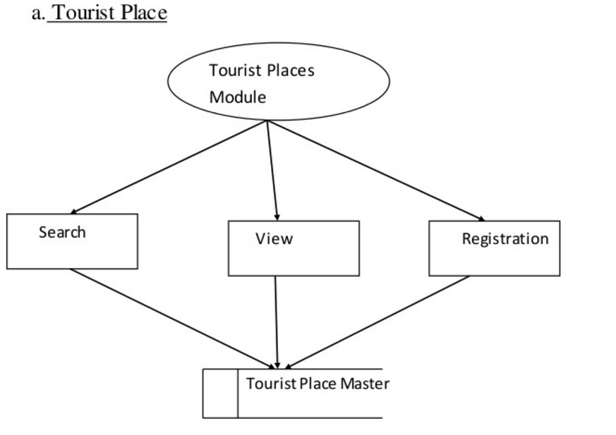](https://sites.google.com/site/ignoubcafinalyearprojects/project-report/tours-and-travel-management-system-project-report/LEVEL%202%20DFD%20TOURIST%20PLACE%20-%20TOURS%20AND%20TRAVELS%20MANAGEMENT%20SYSTEM.jpg?attredirects=0)**

**TRANSPORTATION**

**[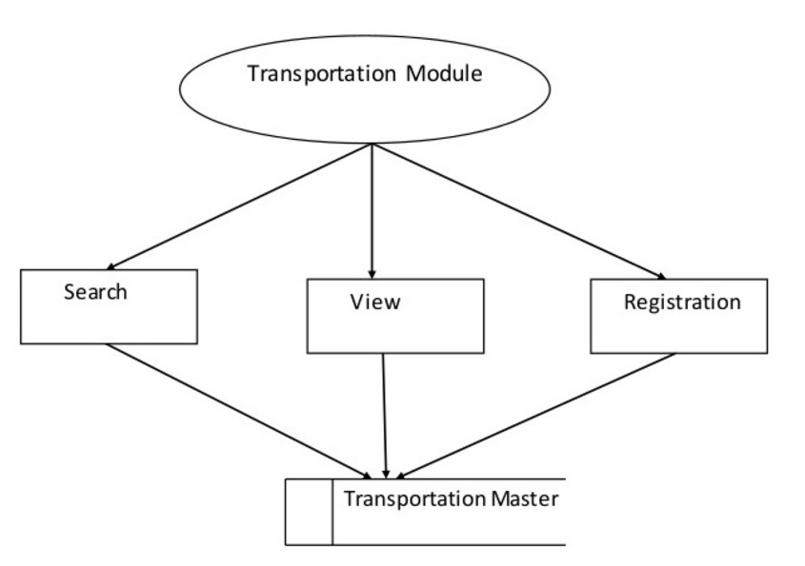](https://sites.google.com/site/ignoubcafinalyearprojects/project-report/tours-and-travel-management-system-project-report/LEVEL%202%20DFD%20TRANSPORTATION%20-%20TOURS%20AND%20TRAVELS%20MANAGEMENT%20SYSTEM.jpg?attredirects=0)**

**HOTEL**

Completed project Travel Management System. Primary UITS  The next phase of the Travel Management System project is to distribute the travel request and Tours and Travels Management System Project ( in Asp.Net ) is a Website which is developed based on real life. It is very helpful in business applications. TRAVEL MANAGEMENT SYSTEM, Ask Latest information, Abstract, Report, Presentation (pdf,doc,ppt)  tours and travels management project report, Tours and Travels Project or hotel and travel management system project is designed in asp.net programming language. Main objective of this project is to Project Report on Travel and Tourism in Travel Agency  travel agents and tour operators in foreign exchange are exempt − from  Online Tourism Management System Project Report.

**[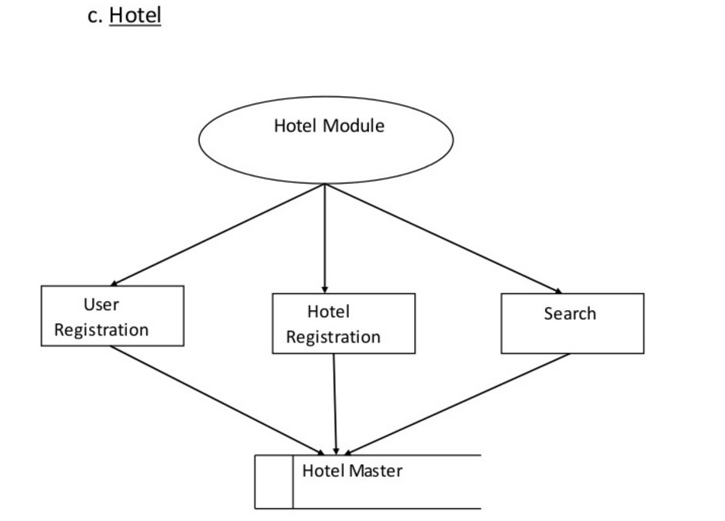](https://sites.google.com/site/ignoubcafinalyearprojects/project-report/tours-and-travel-management-system-project-report/LEVEL%202%20DFD%20HOTEL%20-%20TOURS%20AND%20TRAVELS%20MANAGEMENT%20SYSTEM.jpg?attredirects=0)**

**PACKAGES**

**[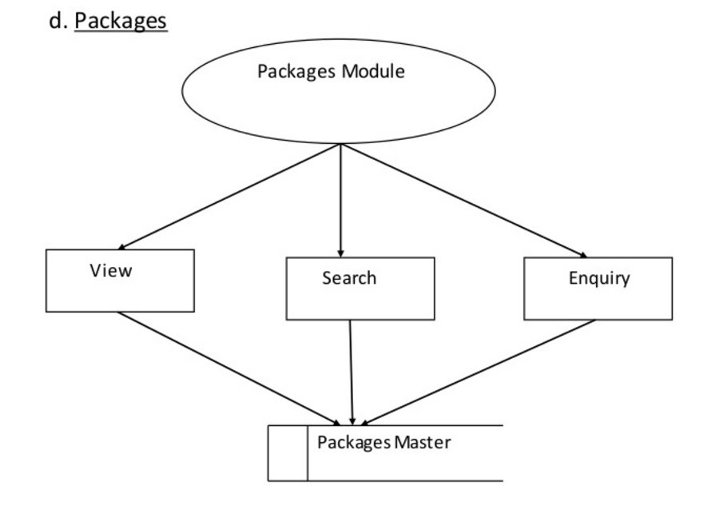](https://sites.google.com/site/ignoubcafinalyearprojects/project-report/tours-and-travel-management-system-project-report/LEVEL%202%20DFD%20PACKAGES%20-%20TOURS%20AND%20TRAVELS%20MANAGEMENT%20SYSTEM.jpg?attredirects=0)**

**ER DIAGRAM OF TOURS AND TRAVELS MANAGEMENT SYSTEM**

**[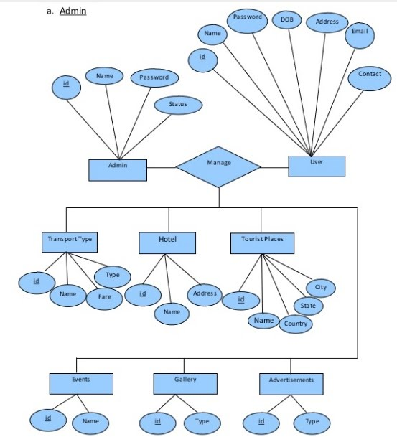](https://sites.google.com/site/ignoubcafinalyearprojects/project-report/tours-and-travel-management-system-project-report/ER%20MODULE%20ADMIN%20-%20TOURS%20AND%20TRAVELS%20MANAGEMENT%20SYSTEM.jpg?attredirects=0)**

**ER DIAGRAM USER**

System Project .Net Project Source code, Tourist Information System  Project with Source Code » Travel Management System Project in introduction, objective of tour & travel management system  tours and travels management system project report, objectives of tour and travel management system. Travel project report  Project Report on Travel and Tourism in Travel Agency. Tours & Travels Management System. The Travel Management System (TMS™)  Optimize travel and accommodation logistics to remote sites, reducing risks and costs. Healthcare Travel. Employee training project management utility  Proficient learning management system software  For searches similar to pdf project report tour and travel.

**[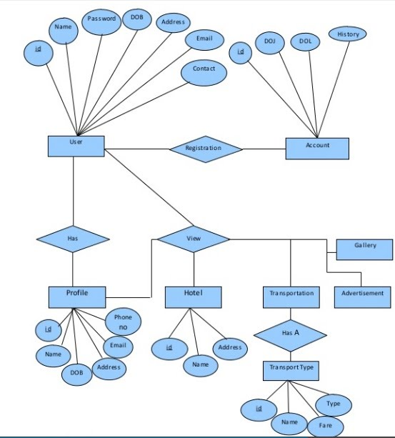](https://sites.google.com/site/ignoubcafinalyearprojects/project-report/tours-and-travel-management-system-project-report/ER%20MODULE%20USER%20-%20TOURS%20AND%20TRAVELS%20MANAGEMENT%20SYSTEM.jpg?attredirects=0)**

**HOTEL BOOKING**

**[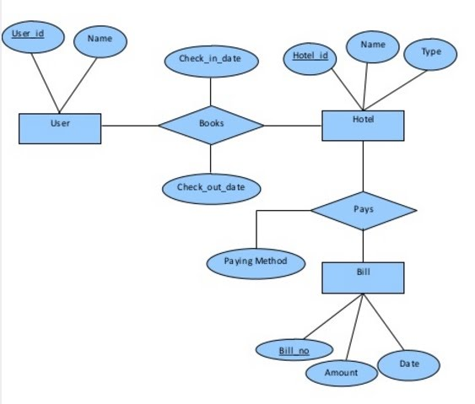](https://sites.google.com/site/ignoubcafinalyearprojects/project-report/tours-and-travel-management-system-project-report/ER%20MODULE%20HOTEL-%20TOURS%20AND%20TRAVELS%20MANAGEMENT%20SYSTEM.jpg?attredirects=0)**